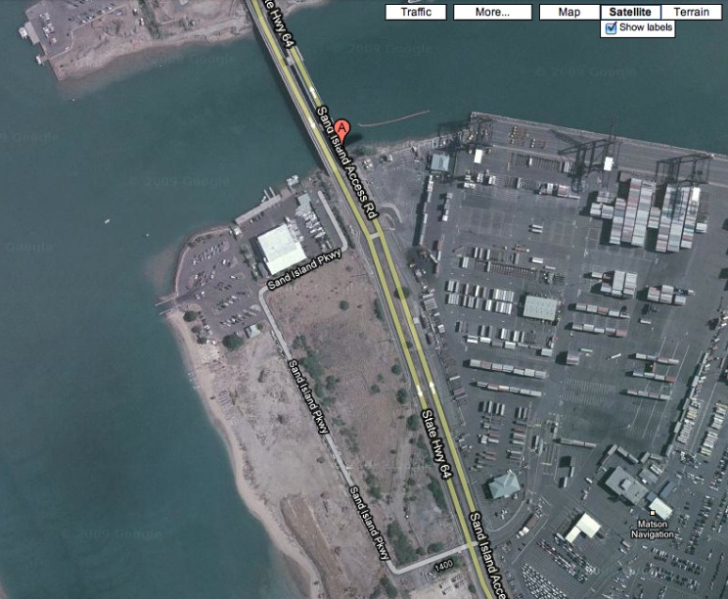

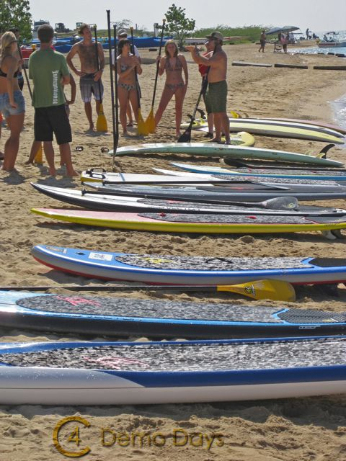
FREE DEMO DAY

SATURDAY, September 18th
8:00 – 10:00 AM
SAND ISLAND PARKWAY MARINE CENTER
(AFTER BRIDGE 1ST RIGHT AT STOP LIGHT)
TRY C4’S NEW BOARDS:
Raimana Pro 9-8
Switchblade 12-6
V1 Racer 14-0

