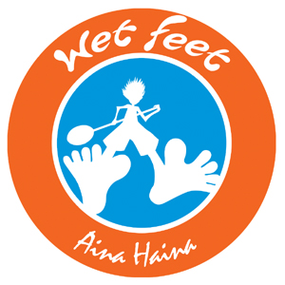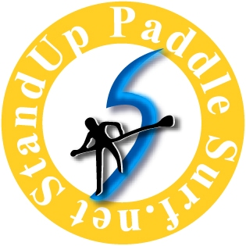



SUPAH Distance Paddling Clinics

Presented by the Stand Up Paddle Association of Hawaii (SUPAH)

an independent non profit organization whose mission is to promote SUP distance paddling, SUP etiquette, and SUP community service events.
Clinic Schedule:
1/24/09 Paddling Technique 1
2/21/09 Paddling Technique 2
3/7/09 Open Ocean Paddling and Bump Riding, Ocean Safety
4/18/09 Equipment and Mock Race
5/16/09 Hawaii Kai to Kaimana Run and Graduation Party
Instructors will be Todd Bradley, Aaron Napoleon, Guy Pere, Morgan Hoesterey, Kainoa Beaupre, Doug Lock and others. Clinics are scheduled on the Saturdays when SUP races are not scheduled. There will be an opportunity to race and car pool with the group at organized events on the other weekends. Clinics will start at 7:30am and go for 3 hours. The format will include instruction and individual coaching along with the opportunity to try various race boards or use your own. All ocean paddling will be escorted. Location will be at Maunalua Bay in Hawaii Kai. Cost is $50 per session or $200 for 5 sessions. Payment can be made at Wet Feet or at the start of any session. Cost includes daily refreshments, paddle shirt, safety whistle, and other goodies. Participants must be 15 years or older. Under 18 must be accompanied by an enrolled adult. Call 255-6255 or 277-5442 for more information.
Name ________________________________ Shirt Size S __ M __ L __ XL __ XXL __
Phone ______________________ Email___________________________________
Gender ______ Age ______ Sessions: 1 ____ 2 ____ 3 ____ 4 ____ 5 ____ All ____
Years Paddling _______ Years SUP _______ Skill Level: Novice 1-2-3-4-5-6-7-8-9-10 Expert

